Stations of the Cross - Davidson

Introduction in the Lady Chapel

Leader: In the name of the Father and of the Son and of the Holy Spirit. Amen

Tonight, we are invited to join our Lord on the Way of the Cross. Experiences change and shape us – and this is no exception. As we walk in the steps of our Saviour and share his journey, so we are invited to reflect on our own lives and the characteristics that make us who we are. Every step we take brings us a step closer to God – as we try to base our lives in his.

Let us pray:

Eternal God, whose Son Jesus Christ is the way, the truth, and the life: grant us to walk in his way, to rejoice in his truth, and to share his risen life; who is alive and reigns, now and for ever. Amen.

As we walk to the First Station, we sing:

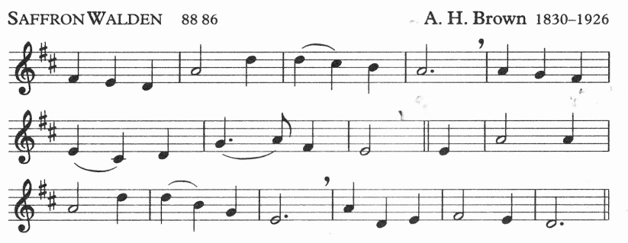

Hymn: Just as I am, without one plea
but that thy blood was shed for me,
and that thou bidst me come to thee,
O Lamb of God, I come.
Just as I am, thou wilt receive,
wilt welcome, pardon, cleanse, relieve:
because thy promise I believe,
O Lamb of God, I come.

1. JESUS IS CONDEMNED TO DEATH - JUDGED

Reader 1: We adore you, O Christ, and we bless you
All: For by your cross, you have redeemed and saved us.

[Pilate ordered Jesus to be scourged and then handed over to be crucified.]

Reader 2: None of us can truly relate to Jesus being led away to be crucified. It is far too severe a sentence for us to comprehend. But many of us do feel sentenced at one time or another in our lives.

Sometimes we spend our lives looking at other people's failures, misfortunes, or mistakes, and make it our business to judge. When we meet up with friends it gives us something to talk about – what Mary so and so down the road is saying and doing – and before long we are discussing her character in depth. We refer to it as gossip and it can take up much of our time together.

But when we become the centre of gossip, the tables are turned and we don't like it at all. We don't like people discussing our every movement and passing judgement on us.

This is because we are then forced to face the truth about ourselves and often it's not too rosy a picture. Perhaps we could spend more time looking at our own faults, weaknesses and character before blackening that of others.
Reader 3: Loving Father, help us to remove the mote from our own eye rather than judge others. As we walk the Way of the Cross, may we constantly follow the example of our Lord and Saviour, Jesus Christ. Amen

As we walk to the next Station, we sing:

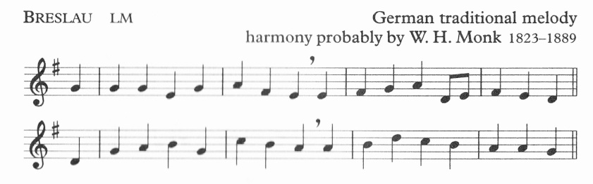

Take up thy cross, the Saviour said,
if thou wouldst my disciple be;
deny thyself, the world forsake,
and humbly follow after me.

2. JESUS TAKES UP HIS CROSS - ACCEPTANCE

Reader 1: We adore you, O Christ, and we bless you
All: For by your cross, you have redeemed and saved us.

[When they had finished mocking him, they took off the cloak and dressed him in his own clothes and led him away to crucify him.]

Reader 2: Everyone has their own personal cross in life. It may be working under someone you don't like, or having to care for an old or difficult relative on a permanent basis.

For some of us those crosses can be very real. Having a partner walk out of a relationship, working under a slave-driver, having your children turn against you or go their separate ways, experiencing loss of any kind, are all crosses to be born. Perhaps those who feel they have the hardest cross to bear are those who have a severe illness. They feel that their life has been taken out of their hands and they have no control over the path they take.

There are many crosses to bear – for some, it could be an addiction, or living with someone who is addicted; or the loss of someone dearly loved. For others, those crosses can be quite trivial – as simple maybe as having to put up with someone who gets on our nerves, experiencing a disappointment in our lives, or having to study for exams.
The message in this station is acceptance. This certainly doesn't mean making yourself a door mat, allowing others to take advantage. But there are times in our lives when it would serve us, and others, better if we accepted our cross without complaining about it quite so much.

Reader 3: Lord of all life, help us to accept the crosses we each have to bear and to do it cheerfully and faithfully, for your Name’s sake. Amen

As we walk to the next Station, we sing [Breslau, p3]:

Take up thy cross: let not its weight
fill thy weak spirit with alarm;
his strength shall bear thy spirit up,
and brace thy heart, and nerve thine arm.

3. JESUS FALLS FOR THE FIRST TIME - WEAKNESS

Reader 1: We adore you, O Christ, and we bless you
All: For by your cross, you have redeemed and saved us.
[It was essential that he should in this way become completely like his brothers so that he could be a compassionate and trustworthy high priest of God's religion, able to atone for human sins. That is, because he has himself been through temptation he is able to help others who are tempted.]

Reader 2: For most of us the hardest thing in life is to show weakness. In the world today where everyone is out to prove themselves, to succeed, earn lots of money and live a comfortable life style, the last thing we want to show each other is weakness.

If we show our weakness to someone we immediately feel we are exposing our vulnerability, admitting we are a failure at something, and proving we are less of a person in the process. Unfortunately we do not see the showing of weakness as a sign of strength.

In the work place for example, more often than not we are too proud to ask for help in case we look stupid. Showing weakness can be as simple as admitting we don't understand something, can't do something, or are afraid of doing something. But it is only by admitting such weakness that we ever learn.

We can show our weakness even in our daily routine with other members of our family. It might be as simple as admitting we were wrong about something, need financial help, or have a problem that needs to be shared.

To show weakness is to show humility. Others may well have useful advice that should be listened to and quite often accepted. It doesn't make you any less of a person to do so – in fact, the opposite is usually true.

Reader 3: Give us the courage, Lord, to let others see our weaknesses and help us to accept advice and help and learn from one another. Amen

As we walk to the next Station, we sing:

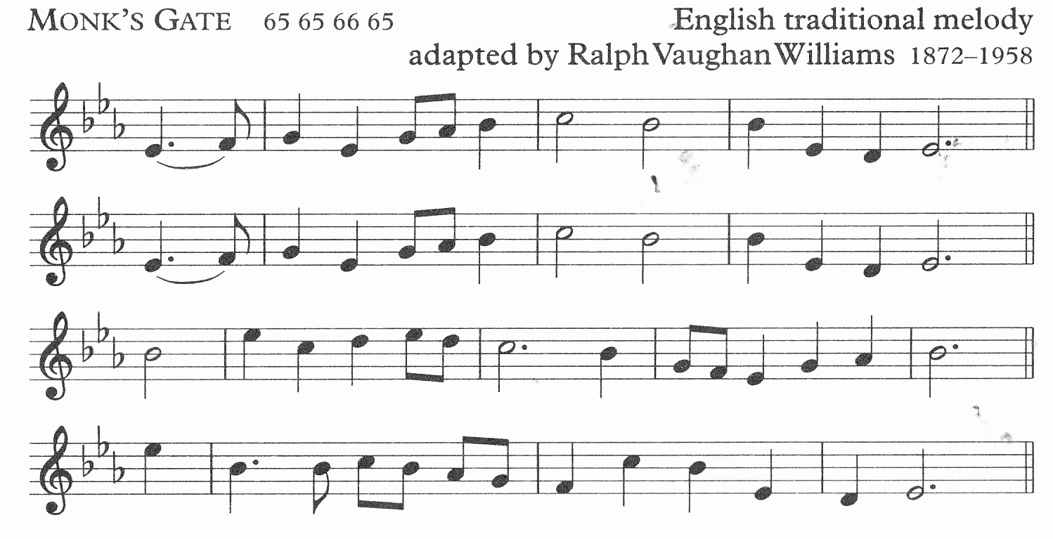

Who would true valour see,
let him come hither;
one here will constant be,
come wind, come weather;
there’s no discouragement
shall make him once relent
his first avowed intent
to be a pilgrim

4. JESUS MEETS HIS MOTHER - LOVE

Reader 1: We adore you, O Christ, and we bless you
All: For by your cross, you have redeemed and saved us.

[The angel said, 'Mary, do not be afraid: you have won God's favour. Listen! You are to conceive and bear a son, and you must name him Jesus.]

Reader 2: In today's world it is extremely difficult not to be completely wrapped up in our own problems and worries. Taking time out to think about others isn't always our first priority as we feel we already have enough on our own plate.

Sometimes when we are surrounded by those we are closest to we are at our most selfish. We believe that if they know and love us so well they, of all people, should be able to accept us, warts and all. If we are miserable, or bad tempered even when it’s not deliberate, we target all our pent up anger against them.

They weren't the instigators of our ill mood, but if they are our family or friends they should understand! The trouble is, we do this to the people we love all the time in our daily lives. Often the people we most dislike are the people we treat most courteously, as we fear they wouldn't put up with us otherwise.

The answer isn't to be ourselves with everyone and let them get on with it, but simply to try and think about ourselves last. We could try to consider other people's feelings and wishes first.

We shouldn't be afraid to show our love for the people who are the most important in our lives, for by giving of love we are losing nothing, and in the end we only stand to gain.

Reader 3: As our Lord loved his mother, so help us to love one another with all our hearts, through him, our Lord Jesus Christ. Amen

As we walk to the next Station, we sing:

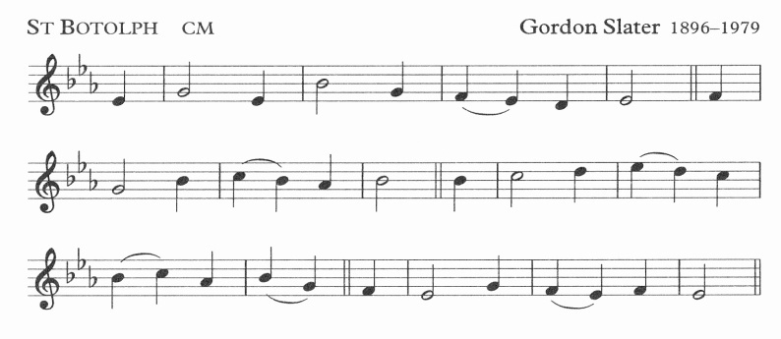

She gave her body as God’s shrine,
her heart to piercing pain;
she knew the cost of love divine,
when Jesus Christ was slain.

5. SIMON OF CYRENE TAKES UP THE CROSS – RESPONSIBILITY & GRATITUDE

Reader 1: We adore you, O Christ, and we bless you
All: For by your cross, you have redeemed and saved us.

[On their way out, they came across a man from Cyrene, Simon by name, and enlisted him to carry his cross.]

Reader 2: You've just settled down in front of the TV, with a mug of hot chocolate, some of your favourite biscuits and that epic film you've been looking forward to all week is just about to start when suddenly someone asks you to give them a lift, do some shopping, make a meal, tell the time, listen to a problem, or maybe the phone rings. In short someone needs your help.

If it was me, I might give that person the help they needed but more often than not, I would make heavy weather of it. I would make sure they knew just how inconvenient it was to do it just then, and how irritated I feel that I'm in no position to say no without looking and feeling selfish.

By the time I have helped that person, they no doubt wish they had never asked in the first place. Looking at it from the other side, how many of us want to smile sweetly and thank the person who pulls a face when asked to do something? The last person you want to show gratitude to is the person who makes it obvious they didn't want to do it in the first place.

The message of this Station is to be generous in your giving.

Reader 3: Instil within each one of us, O Lord, a generosity of spirit and a willingness to serve others, for in serving them, we are also serving you. Amen

As we walk to the next Station, we sing:

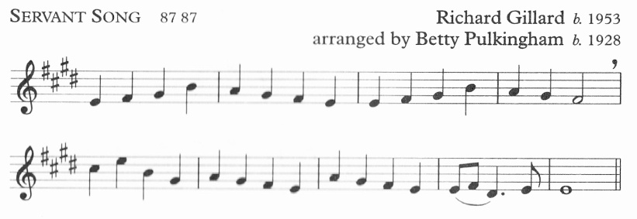

Brother, sister, let me serve you,
let me be as Christ to you,
pray that I may have the grace
to let you be my servant too.

6. VERONICA WIPES THE FACE OF JESUS – BRAVERY

Reader 1: We adore you, O Christ, and we bless you
All: For by your cross, you have redeemed and saved us.

[And the King will answer, I tell you solemnly, in so far as you did this to one of the least of these brothers of mine, you did it to me.']

Reader 2: In society today when someone is ridiculing another, putting them down, making racist or defamatory comments, it is easier to keep quiet and say nothing, even if our own blood is boiling and we feel they are grossly unfair in what they are saying.

We find it easier to go with the crowd, not draw attention to ourselves, not be the odd one out, for if we do, we might become the focus for ridicule ourselves.

But if we see another person persecuted, we know we should fly to their help, no matter how it may impact on ourselves, We should stand up for what is right, or at least what we believe to be right, even if we are mistaken.

People with their prejudices, to give them any credit at all, are at least being true to their own beliefs, however distorted they may be. We should be true to ours.

Reader 3: Lord, how often we fail to act when we know we should. Give us the courage to act, even when we are afraid. Amen.

As we walk to the next Station, we sing [Servant Song, p9]:

We are pilgrims on a journey,
fellow trav’llers on the road;
we are here to help each other
walk the mile and bear the load.

7. JESUS FALLS FOR THE SECOND TIME-PERSEVERANCE

Reader 1: We adore you, O Christ, and we bless you
All: For by your cross, you have redeemed and saved us.

[He was pierced through for our faults, crushed for our sins.]

Reader 2: Failure is one of the most difficult hurdles to overcome. It leads to the loss of confidence, making us believe we cannot succeed in the future.
If we find an exam easy, or have a good day at work, we often look forward to the next day, and go in with a singular determination to do even better. More often than not, that's exactly what we do. Where there’s a will, there's a way.

On the other hand, if we under-achieve we immediately question the point of carrying on.

Failing at something can be as simple as arriving late for work more times than you can remember, doing badly in an exam, forgetting something important you were supposed to do. It could also mean failing an interview, driving test, not completing a course, or anything you have put off for so long that you feel you can no longer make a start.

That start could be doing the housework, getting in touch with an old friend or relative, visiting someone who you know is in need of your friendship, forgiving someone. It could even be that diet you've meant to do for so long.
It doesn’t matter how trivial it may seem, it’s the determination to pick up from where you last left off, and faced with the possibility of failure, still try once more. If at first you don’t succeed, try, try, try again.

Reader 3: At times when we have failed, may we remember that our Lord picked himself up again and again as he journeyed to Calvary. Let us never lose heart but determine to do your will in all things; through Jesus Christ our Lord. Amen

As we walk to the next Station, we sing [Servant Song, p9]:

I will hold the Christlight for you
in the night-time of your fear;
I will hold my hand out to you,
speak the peace you long to hear.

8. JESUS MEETS WOMEN OF JERUSALEM - LOYALTY

Reader 1: We adore you, O Christ, and we bless you
All: For by your cross, you have redeemed and saved us.

[Large numbers of people followed him, and of women too, who mourned and lamented for him. But Jesus turned to them and said. 'Daughters of Jerusalem, do not weep for me: weep rather for yourselves and for your children...']

Reader 2: Loyalty is one of the most important qualities in our lives. We know that when we are in times of trouble, or need a shoulder to cry on, our friends are those we can always rely on.

The same is true, if not more so, of our family. They will stick with us through thick and thin, no matter what, as they love us. But such loyalty is sometimes hard to return.

Loyalty can be as simple as keeping a secret for someone, defending a friend in an argument, not believing gossip about a close friend or family member, or even giving support to someone we love though we know they are in the wrong.

To be loyal to someone means to stand by them, to always think the best of someone no matter what the circumstance To believe there is good in everyone.

Loyalty is something we all hold precious .We all make many acquaintances in life, but it is always those we feel we can most trust that we believe to be our true friends. And they, in turn, should feel the same about us,

Reader 3: Lord Jesus, you are a true friend to all who put their trust in you: help us to respond to your love and be loyal to those around us, for your Name’s sake. Amen

As we walk to the next Station, we sing [Servant Song, p9]:

I will weep when you are weeping;
when you laugh, I’ll laugh with you.
I will share your joy and sorrow
till we’ve seen this journey through.

9. JESUS FALLS A THIRD TIME - DESPAIR

Reader 1: We adore you, O Christ, and we bless you
All: For by your cross, you have redeemed and saved us.

[He had not done anything wrong, and there had been no perjury in his mouth. He was insulted and did not retaliate with insults: when he was tortured he made no threats but he put his trust in the righteous judge.]

Leader 2: For those with real addictions, it must seem as though there will be no end to falling down. It is often something in their lives that has propelled them towards needing to take a substitute. They feel they have lost some quality of life and so need to substitute it with something else.

It is often said that those addicted to alcohol, drink to forget. They want to block out all remembrance of what it is that pains them, what has made them despair of life. They want to escape into a warm make-believe world where everything seems cheerful and no one can hurt them again. They may think it works for them, but really it kills them and others who live with them.

Addiction of any kind is the substitute for company, love, self respect, and hope. Those who are addicted are dependant on something that helps them make it through to the next day. They need something solid to look forward to. because all other hope of life has been lost.

For those living with an addiction, the thought of living a normal life without a substitute to dull their pain, whatever it may be, is often too much to bear. The fear for them is the thought of never being able to get up again on their own.

Reader 3: Lord, may we never give up on you or on ourselves. Help us to love, even when we find it hard. Amen.

As we walk to the next Station, we sing [Servant Song, p9]:

When we sing to God in heaven,
we shall find such harmony,
born of all we’ve known together
of Christ’s love and agony.

10. JESUS IS STRIPPED OF HIS CLOTHES - VULNERABILITY

Reader 1: We adore you, O Christ, and we bless you
All: For by your cross, you have redeemed and saved us.

[They took his clothing and divided it into four shares, one for each soldier. His undergarment was seamless, woven in one piece from neck to hem: so they said to one another, 'instead of tearing it, let's throw dice to decide who is to have it'.]

Reader 2: Today, in the age of Lottery Fever, it is extremely difficult not to crave windfall, imagine that extra house, large garden, swimming pool, or cruise around the Mediterranean.

Even those with money, real money, stake their bet, be it on the Grand National, the Lottery, or the local bingo. Everyone wants to be rich, because money stands for success and happiness, and we get greedy.

If we have a small win, we immediately declare “My luck must be in” and then spend the amount we have just won on more chances of winning even more. We are never satisfied, we always want more. We are driven by greed.

If it's not gambling then it's ambition in the work place. Frequently, people have no scruples about treating another person if it means promotion for themselves. The argument is "They would do the same if they were in my shoes”, and more often than not they are right.

It is important to learn to be more selfless, to be happy with our lot and not constantly hunger for more money. We should strip away all our worldly desires if we are to focus on what is really important in life

Reader 3: Remove from us, O Lord, all greed and selfishness and help us to put the good of others before what we want. Amen

As we walk to the next Station, we sing [Saffron Walden, p1]:

Just as I am, poor, wretched, blind;
sight, riches, healing of the mind,
yea, all I need, in thee to find,
O Lamb of God, I come.

11. JESUS IS NAILED TO THE CROSS - FIXED

Reader 1: We adore you, O Christ, and we bless you
All: For by your cross, you have redeemed and saved us.

[When the reached the place called The Skull, they crucified him there and the two criminals also, one on the right, the other on the left. Jesus said. 'Father, forgive them: they do not know what they are doing.' ]

Reader 2: It is easy to feel and show sympathy for the homeless person in the street who you feel has an unfair lot in life. But to feel sympathy for someone who you believe has only got themselves to blame for the position they find themselves in is much more difficult.

Having the time to feel sympathy or empathy for another may seem too much of an effort, especially when engrossed in our own problems of the day. Sometimes a friend will seek us out in their hour of need. More often than not, all that person wants is for someone to listen to them, someone to share with them their feelings of being fixed or imprisoned in their lives.

It could be anyone who feels tied through duty or love. They feel fixed to their cross. It could be a woman who remains with the husband who repeatedly beats her, for the children's sake; or the wife or husband who sticks with their partner who repeatedly cheats on them or treats them badly.

It may relate to parents who support their children, even when they do wrong, or who care for their sick or disabled child throughout his or her life, or day in day out care of an elderly relative.

This is when they most need someone to help bear their huge burden.

Reader 3: Help us, Father, to recognise when others are struggling under the weight of their cross and respond with sensitivity and true compassion. Amen

As we walk to the next Station, we sing:
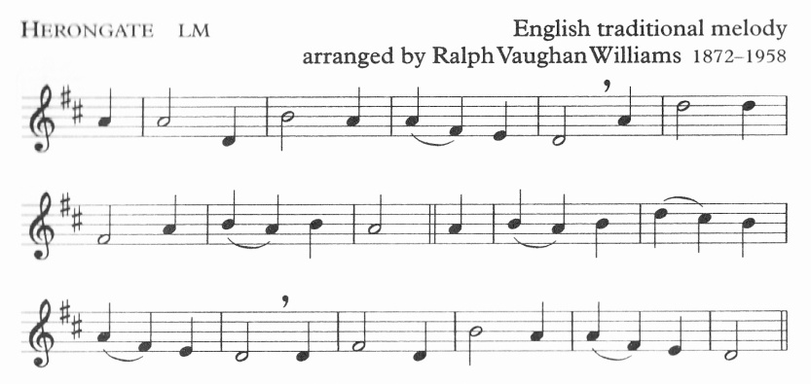

I sometimes think about the cross,
and shut my eyes, and try to see
the cruel nails and crown of thorns
and Jesus crucified for me.

12. JESUS DIES ON THE CROSS - OPTIMISM

Reader 1: We adore you, O Christ, and we bless you
All: For by your cross, you have redeemed and saved us.

[When Jesus had cried out in a loud voice, he said. 'Father, into your hands I commit my spirit'. With these words he breathed his last.]

Reader 2: People need things to look forward to, occasions to work towards. When we take holidays, there is a sense of anticipation as we count down the days to the break we have worked towards for so long.

It doesn't matter where we go, it could be Blackpool, Barbados, or the back garden, so long as it is something we can all look forward to. But almost as soon as we are enjoying our break, we start thinking about it soon being over. We dread the good times coming to an end, and as it is something which will inevitably take place, it hangs over us like a dark black cloud.

Many of us spend too much time living in the future rather than the present. If we are not dreading what is round the corner, we are wishing our lives away until the next happy occasion.

Many of us see death as the dreadful inevitable. It happens to all of us; it's not the most comforting notion, and you can't escape it.

Death seems like an end to living, the good times coming to a close. But death can be seen as the release of the soul, a time when, however you want to comprehend it you are at peace with your life as it is then, in the present. There is no longer a race for the finishing line, or something to dread, but peace. And until then, that is how we should and must view life, being at peace with ourselves, living in the present.
Reader 3: Give us, we pray Lord Jesus, a sense of contentment as we try to live in the present, and a peace that comes through faith in your redeeming work. Amen

As we walk to the next Station, we sing [St Botolph, p8]:

Hail, Mary, you are full of grace,
above all women blest;
and blest your Son, whom your embrace
in birth and death confessed.

13. JESUS’ BODY IS PLACED IN THE ARMS OF MARY - LONELINESS

Reader 1: We adore you, O Christ, and we bless you
All: For by your cross, you have redeemed and saved us.

[After this, Joseph of Arimathaea, who was a disciple of Jesus though a secret one because he was afraid of the Jews, asked Pilate to let him remove the body of Jesus. Pilate gave permission, so they came and took it away].

Reader 2: Even if none of us have had to experience the great tragedy of losing a child we all know the desperate sorrow you feel when losing a member of the family, like a grandparent, a friend, or even a family pet.

Suddenly we are left with an empty shell, a cruel reminder of their great vitality for life - their talents, humour, character all apparently gone. It can seem even more devastating if it's a small baby with his or her life before them, or a youngster, or teenager who was just starting to make their first real choices in life about who they wanted to be.

The obvious feeling, is ‘what was the point?’. Why live to die? There is no answer that will adequately comfort anyone in that position. Everyone's bereavement is different from another's and everyone's pain is very different.

Some people are faced with loneliness for the first time in their lives and a simple task of going to the shops on their own to buy some food can seem too much. They shrink into themselves and before long lose all self respect, and no longer look after themselves. They feel they no longer have anything to live for.

The overriding feeling for those experiencing bereavement in whatever way or form is one of being left desperately alone. They need something to hold on to – something to grasp. They need a lifeline to help them through.

Reader 3: At times of loss or loneliness, help us to cling on to you; and when others need your presence, may we bring them into your eternal presence, where true hope is to be found. Amen

As we walk to the next Station, we sing:

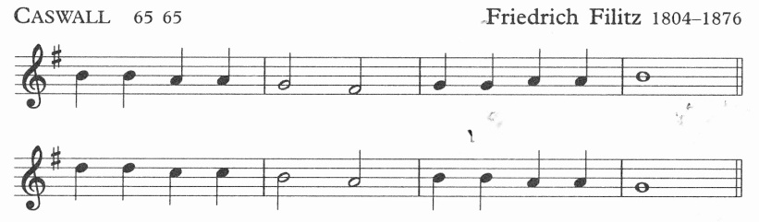

Glory be to Jesus,
who, in bitter pains,
poured for me the life-blood
from his sacred veins.

14. JESUS IS LAID IN THE SEPULCHRE – REMEMBRANCE

Reader 1: We adore you, O Christ, and we bless you
All: For by your cross, you have redeemed and saved us.

[They took the body of Jesus and wrapped it with the spices in linen cloths, following the Jewish burial custom. At the place where he had been crucified there was a garden, and in this garden a new tomb in which no one had yet been buried. Since it was the Jewish Day of Preparation and the tomb was near at hand, they laid Jesus there.]

Reader 2: No matter how much we love someone, we fear that their memory will fade with the passing of time.

People want to imagine them exactly as they were before they died. How they laughed, the colour of their eyes, the way their hair fell, everything. At first, we want to remember everything about them so we feel as though we could just reach out and touch them.

We will often root out our latest photographs of them or if lucky enough will look at a video we have taken of them. We want to remember them and honour them in some way which is why we still remember their anniversaries, light candles for them, visit their grave and plant flowers or a tree as a mark of respect.
How often people regret that they didn't say then how much they loved and respected that person. Perhaps the true message of this Station is to honour and respect not only those who have since died but those still living. We perhaps should show just as much honour and respect to those around us, the people we meet and who share our everyday lives – friends, family and even strangers.

Reader 3: God of the living and of the dead, help us to see your image in one another and to respond with kindness and love. Amen

During Lent, the pilgrims return to the Lady Chapel, singing:

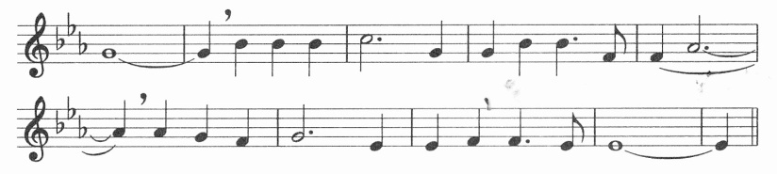

Be still, my soul: the Lord is at your side;
bear patiently the cross of grief and pain;
leave to your God to order and provide;
in every change he faithful will remain.
Be still, my soul: your best, your heavenly friend
through thorny ways leads to a joyful end.

Leader: This is where our journey ends tonight, yet with the eyes of faith, we know the journey continues and leads us to new heights of awareness, faith and joy.

In the early Church, the cross was seen as a sign of victory. Some Stations of the Cross now celebrate a fifteenth station to make this point. Life doesn’t always take us along a smooth path, nor does it always seem fair. As we walk the Way of the Cross, the people who walked with our Lord remind us that we never walk alone. Indeed, we are in a privileged position in that our Lord walks with us.

Priest: Through the cross you brought joy into the world
All: We worship you Lord, we venerate your cross, we praise your resurrection.

Priest: Most merciful God, who by the death and resurrection of your Son Jesus Christ delivered and saved the world: grant that by faith in him who suffered on the cross, we may triumph in the power of his victory; through Jesus Christ our Lord. Amen

Christ give you grace to grow in holiness, to deny yourselves, take up your cross, and follow him; and the blessing of God almighty, the Father, the Son and the Holy Spirit, be among you and remain with you always. Amen

    

15. JESUS RISES FROM THE DEAD – BIRTH

Reader 1: Through the cross you brought joy into the world
All: We worship you Lord, we venerate your cross, we praise your resurrection.

In the early Church, the cross was seen as a sign of victory. Some Stations of the Cross now celebrate a 15th station to make this point.

By marking this last station we are acknowledging the reason for why Jesus went through the other Stations of the Cross, why he bore the suffering and pain, to give us the chance of new life, and to prove his power over death.

Sometimes it is very difficult for us to break with tradition. We know what we like and often we become set in our ways. Often we can become immovable and in so doing so alienate ourselves from others.

It can be as simple as not fully welcoming another member into your family circle, be it a new neighbour offering friendship, or a young person marrying into your close immediate circle, a child watching a parent taking a new wife or husband after being left widowed, or one religion finding difficulty in embracing another.

But this station can also relate to someone left alone, who has become so used to their own company they know and want no better. They shut out the outside world to feel secure in their own presence. The message is to reach out to others and make a brand new start in life.

In it's rawest sense it can mean an awakening, opening our eyes to what is around us and rejoicing in what we have, and life all around us.

